DIGITAL MARKETING ASSIGNMENT- 1

Create a blog or website using Blogspot and WordPress. Customize the theme design and post new article with 500 words.

|  |  |
| --- | --- |
| Name | Abi Dharshini. K |
| Reg. No | 960220106004 |
| NM ID | E6A8D78DE88CF2D80454068BBAB16927 |
| Team ID | NM2023TMID02411 |

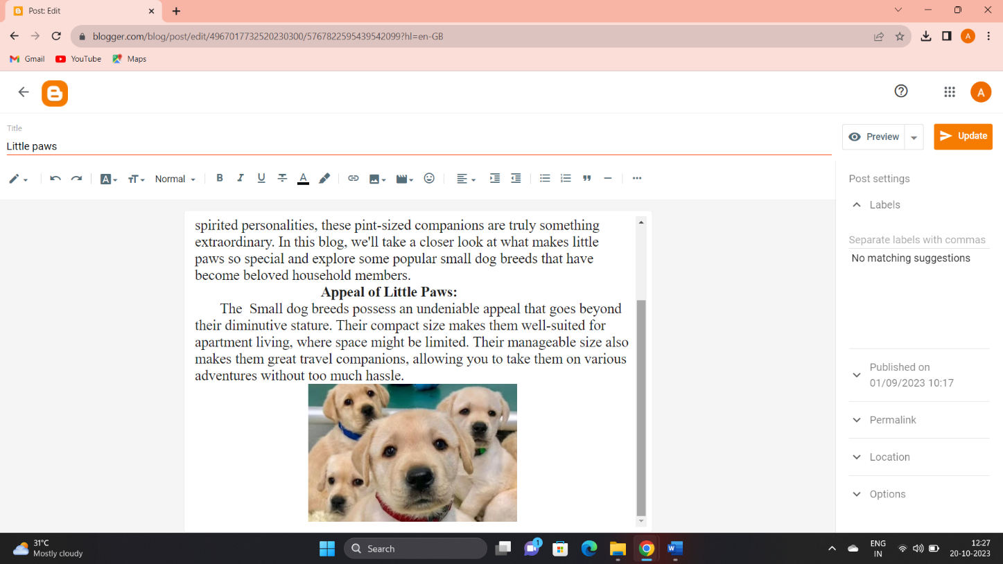Blogger: <https://www.blogger.com/blog/post/edit/4967017732520230300/5767822595439542099?hl=en-GB>

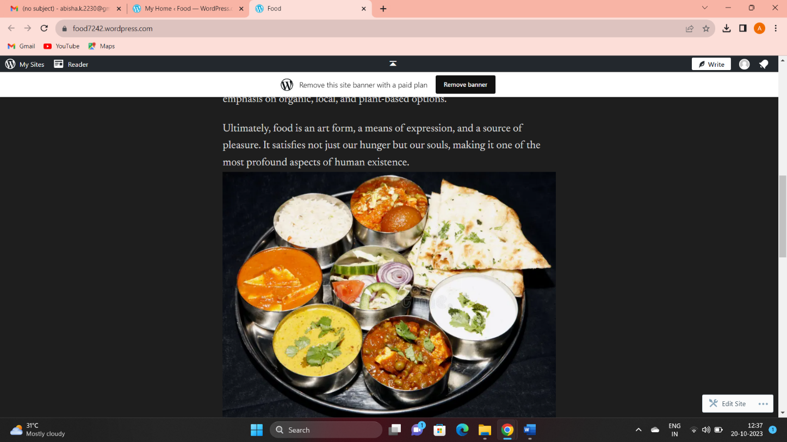WordPress: <https://food7242.wordpress.com/>